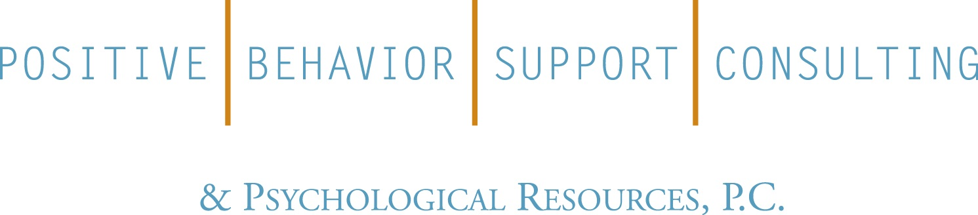
410 Fort Salonga Road
Northport, NY 11768
631-262-8561
www.positivebehavior.org

Positive Behavior Support Consulting & Psychological Resources, P.C.

Presents

BCBA Supervision CEU Training
This training is adapted from a comprehensive curriculum for BCBA supervisors in use at California State University (CSUN) and is designed as a tool for those providing supervision to BCBA supervisees. This training follows the BACB Task List and also includes suggested readings and videos to support various curriculum topics. This approach addresses the requirement for a planned programmed sequence of supervised experience as outlined in the NYS licensing laws for Behavior Analysts.
Presented by Christopher Smith, PhD, LBA, BCBA-D. Dr. Smith is a New York State licensed clinical psychologist and is the Director of Professional Development for PBS Consulting & Psychological Services, P.C.

December 13, 2017

6:30 p.m. – 9:00 p.m. Cost: $90

3 BCBA Supervisor Credit Hours

Location:

PBS Consulting & Psychological Resources, P.C.

410 Fort Salonga Road

Northport, NY 11768

PBS is an approved continuing education (ACE) provider for the New York State Education Department and the Behavior Analysis Certification Board. We are also an approved Independent Fieldwork provider for several programs offering BCBA certification.

To register, go to http://www.positivebehavior.org/professional-development.html

